EVENTFORCE – SALESFORCE EVENT MANAGEMENT SYSTEM

Final-Year B.Tech Engineering Project Report
Team Member's Name: VetriSelvan G, Aswini M, Gopika K, LakshmiKeerthana S, Hemalatha A
Register Number: 212423243029, 212423243005, 212423243006, 212423243016, 212423243011
Department: B.Tech Artificial Intelligence and Data Science
Institution: Sree Sastha Institute Of Engineering And Technology
Academic Year: 2026
Platform: Salesforce Developer Edition

TABLE OF CONTENTS
1. INTRODUCTION 2
2. PROJECT OBJECTIVES 3
3. PROJECT SCOPE 3
4. TECHNOLOGIES USED 4
5. SYSTEM ARCHITECTURE / DATA MODEL 5
6. OBJECTS AND FIELDS 6
7. IMPLEMENTATION PHASES 10
8. AUTOMATION 11
9. SECURITY AND ACCESS CONTROL 17
10. DATA IMPLEMENTATION 20
11. REPORTS 22
12. DASHBOARD 23
13. TESTING AND RESULTS 25
14. SCREENSHOT EVIDENCE 27
15. DEPLOYMENT AND MAINTENANCE 29
17. FUTURE ENHANCEMENTS 31
18. CONCLUSION 32
19. REFERENCES 32
20. APPENDIX A: IMPLEMENTATION EVIDENCE INDEX 32
21. DOCUMENT CONTROL NOTE 33

ABSTRACT
EventForce is a Salesforce-based CRM solution intended to digitize and automate event-management operations for Event Planner Solutions. Based on the reference implementation, the system centralizes client bookings, venue reservations, vendor coordination, feedback collection, event scheduling, cancellation approvals, reminders, security controls, reports, and dashboards in one platform. The implementation combines Salesforce custom objects and relationships with declarative automation, Apex classes and triggers, approval processing, validation rules, role-based access, and operational analytics. The reference document states expected business value including a 60% reduction in manual processes, a 40% improvement in booking efficiency, improved client satisfaction through timely communication, and data-driven visibility for growth. These percentages are project objectives from the reference and are not measured test results.
Source boundary: This report distinguishes documented configuration, screenshot evidence, and outcomes that were not provided. Where execution evidence is unavailable, the report states “Configured; execution evidence not provided” or “Not provided.”

1. INTRODUCTION
The EventForce Management System is a Salesforce CRM designed to manage event-planning activities through centralized data, automation, collaboration, and reporting. It coordinates clients, events, vendors, venues, and feedback within a single platform while reducing manual coordination and improving operational visibility. The implementation was built in a Salesforce Developer Edition org for academic purposes.
The reference implementation covers custom data modeling, event scheduling, venue reservations, vendor coordination, feedback collection, cancellation approvals, client reminders, access control, reporting, and dashboard visualization. It combines declarative Salesforce configuration with Apex logic for business rules that require programmatic processing.

2. PROJECT OBJECTIVES
- Digitize and automate event-management operations.
- Centralize client bookings, venue reservations, vendor coordination, and feedback collection.
- Improve collaboration among event coordinators, vendor managers, clients, venue managers, and administrators.
- Automate event scheduling, reminders, cancellation approvals, and related updates.
- Improve data accuracy through validation rules and formula fields.
- Provide operational visibility through reports and dashboards.
- Support controlled access through profiles, roles, permission sets, organization-wide defaults, and sharing rules.
- Target a 60% reduction in manual processes and a 40% improvement in booking efficiency. These are intended business targets, not measured outcomes.

3. PROJECT SCOPE
Area | Scope and evidence boundary
Event management | Event records, dates, types, statuses, budgets, clients, and venues.
Client management | Client identity and contact information used in event and feedback relationships.
Vendor management | Vendor services and status, linked to events through EventVendor__c.
Venue management | Venue information, capacity, location, and availability status.
Feedback | Ratings, comments, and links to clients and events.
Automation | Reminder flow, approval process, validation rule, Apex classes, triggers, and scheduled Apex described in the reference.
Security and analytics | Profiles, roles, permission sets, sharing controls, reports, and dashboards.

4. TECHNOLOGIES USED
Technology or Salesforce capability | Use in EventForce
Salesforce Developer Edition | Academic development and configuration environment.
Salesforce Lightning interface and Lightning App | Workspace for accessing event-management modules.
Custom objects and fields | Storage of event, client, vendor, venue, feedback, and junction records.
Lookup and Master-Detail relationships | Relationship modeling and the Event–Vendor many-to-many design.
Record-Triggered Flow | Scheduled client reminder before a confirmed event.
Validation Rules and Formula Fields | Data-quality enforcement and event budget calculation.
Approval Processes, Email Templates, and Email Alerts | Event cancellation review and notifications.
Apex Classes and Triggers | Venue status updates and double-booking prevention.
Batchable and Schedulable Apex | Past-event completion processing.
Reports and Dashboards | Upcoming event analysis and operational visualization.
Profiles, Roles, Permission Sets, OWD, and Sharing Rules | Role-based access and record visibility.
Data Import Wizard | Data migration approach described in the reference document.

5. SYSTEM ARCHITECTURE / DATA MODEL
The system uses six custom objects. Event__c is the central operational object. Client__c and Venue__c are related to events through lookup relationships. Feedback__c records are related to both events and clients. EventVendor__c acts as the junction object between Event__c and Vendor__c through two Master-Detail relationships.
Architecture relationship
Client__c 1 — lookup — * Event__c
Venue__c 1 — lookup — * Event__c
Event__c 1 — lookup — * Feedback__c
Client__c 1 — lookup — * Feedback__c
Event__c 1 — master-detail — * EventVendor__c * — master-detail — 1 Vendor__c

Relationship | Type
Event → Client | Lookup
Event → Venue | Lookup
Feedback → Event | Lookup
Feedback → Client | Lookup
EventVendor → Event | Master-Detail
EventVendor → Vendor | Master-Detail
The Feedback Event lookup includes the documented lookup filter that restricts available events to those belonging to the selected Client. This supports consistent client-event data entry.

6. OBJECTS AND FIELDS
6.1 Event (Event__c)
Field or behavior | Definition | Relationship
Event Name | Record name. | —
Event Date | Date field. | Used by reminder and reporting logic.
Event Type | Picklist: Wedding, Corporate, Birthday, Anniversary, Festival, Concert, Other. | —
Event Status | Picklist: Planned, Confirmed, Completed, Pending Cancellation, Canceled, Rejected. | Used by flows, approvals, and Apex logic.
Event Budget | Formula currency field calculated from Event Type. | —
Client and Venue | Lookup fields. | Client__c and Venue__c.
The Event Budget formula uses CASE(TEXT(Event_Type__c)): Wedding 50000; Corporate 30000; Birthday 10000; Anniversary 20000; Festival 60000; Concert 40000; Other 15000; default 0. The reference defines the return type as Currency and does not establish a separate currency convention.
6.2 Client (Client__c)
Key fields | Behavior and relationships
Client Name, Email, Phone, Address, Country, City | Client contact and location data. Client__c is linked to Event__c and Feedback__c through lookup relationships.
6.3 Vendor (Vendor__c)
Key fields | Supported values and relationships
Vendor Name, Email, Phone | Vendor identity and contact fields.
Service Type | Multi-select picklist: Catering, Decor, Photography, Videography, Lighting, Stage Setup, Makeup Artist, DJ/Music, Transportation, Hosting/Anchor.
Status | Picklist: Available, Booked, Cancelled.
Event relationship | Implemented through EventVendor__c.
6.4 Venue (Venue__c)
Key fields | Definition
Venue Name, Address, Location | Location is a URL field.
Capacity | Number field.
Availability Status | Picklist: Available, Reserved, Not Available.
6.5 Feedback (Feedback__c)
Key fields | Definition
Feedback ID | Auto Number with display format F-{0000}, starting number 0.
Rating | Picklist values 1, 2, 3, 4, 5.
Comments | Long Text field.
Event and Client | Lookup relationships to Event__c and Client__c.
6.6 EventVendor (EventVendor__c)
EventVendor__c is the junction object implementing the many-to-many Event–Vendor relationship. It contains Event and Vendor Master-Detail relationships as specified in the reference.
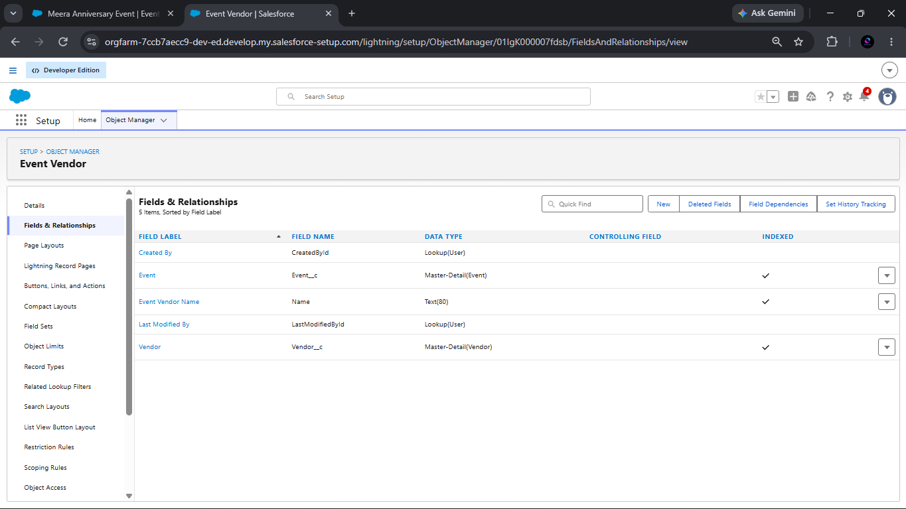
Figure 1. Salesforce configuration evidence for the EventVendor__c junction object.
The screenshot is evidence of the Event Vendor fields and relationship configuration. It is included as a placeholder because the responsive document cannot directly embed the uploaded image.

7. IMPLEMENTATION PHASES
7.1 Phase 1: Requirement Analysis and Planning
Phase 1 defined the EventForce business objective, functional scope, stakeholder responsibilities, and execution roadmap. The planned scope included Event, Client, Vendor, Venue, Feedback, and EventVendor objects; Lookup, Master-Detail, and many-to-many relationship modeling; flows for reminders and updates; validation and formula fields; cancellation approvals; access controls; and reports and dashboards.
Stakeholders identified in the reference are Clients, Event Coordinators, Vendors, Venue Managers, and Event Administrators. The roadmap moved from object and field setup to automation, validation, access, approval processing, Apex logic, and analytics.
7.2 Phase 2: Backend Development and Configurations
Phase 2 established the Salesforce Developer Edition account and configured the custom objects, fields, relationships, lookup filter, validation rule, approval process, reminder flow, Apex classes, triggers, and batch/scheduled Apex. Declarative configuration handled standard business processes, while Apex addressed venue availability, double-booking prevention, and past-event completion.
The reference also documents Classic Email Templates and Email Alerts for cancellation approval communication. Configuration evidence is referenced in the automation and security sections of this report.
7.3 Phase 3: UI/UX Development and Customization
Phase 3 focused on a simple Salesforce Lightning workspace for event operations. The reference describes the Event Planner app and navigation items for Events, Clients, Vendors, Venues, Feedback, Reports, and Dashboards. Reports and dashboards were developed to support event schedules, budget visibility, vendor-related operations, and client feedback monitoring.
7.4 Phase 4: Data Migration, Testing and Security
Phase 4 covered data loading through the Data Import Wizard, user creation, profiles, roles, permission sets, Organization-Wide Defaults, sharing rules, and validation of data accuracy, automation, and permissions. The reference states that Event records were configured with Private organization-wide access and controlled sharing.
7.5 Phase 5: Deployment, Documentation and Maintenance
Phase 5 treated the Developer Edition org as an academic deployment simulation. Metadata including objects, fields, flows, Apex, reports, and dashboards was structured for future migration. Maintenance activities included monitoring automation, troubleshooting permissions, debugging Apex and flows, and adjusting validation or sharing settings as business needs evolve.

8. AUTOMATION
8.1 3-Day Event Reminder Flow
The Record-Triggered Flow operates on Event records created or updated with Event Status = Confirmed. It uses Event Date as the time source and a scheduled path named 3_Days_Before with an offset of three days before the event. The flow sends an email to Client Email and CCs the Event Owner using the Subject and Body text resources described in the reference.
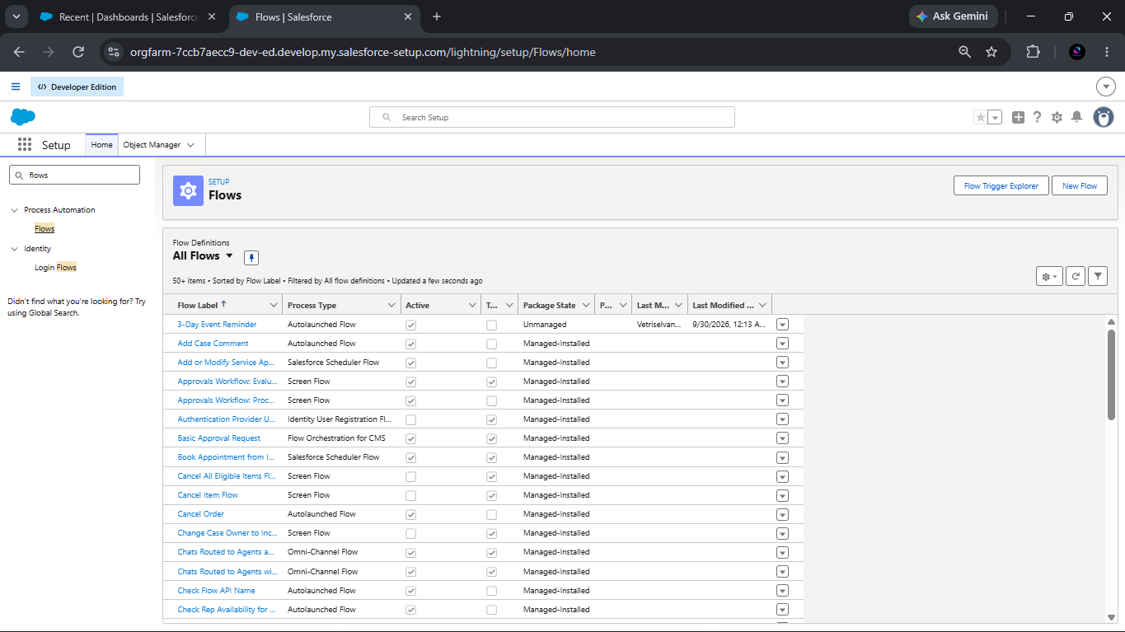
Figure 2. Salesforce Flow configuration showing the Event reminder automation.
The screenshot demonstrates that the reminder flow exists. Email delivery or execution results were not provided.
8.2 Venue Double-Booking Prevention
The PreventDoubleBooking before-insert and before-update trigger checks Event__c records that share a Venue and Event Date. When a conflict is identified, it adds the error “This Venue is already booked on this date.” The implementation is configured to prevent two events at the same venue on the same date.
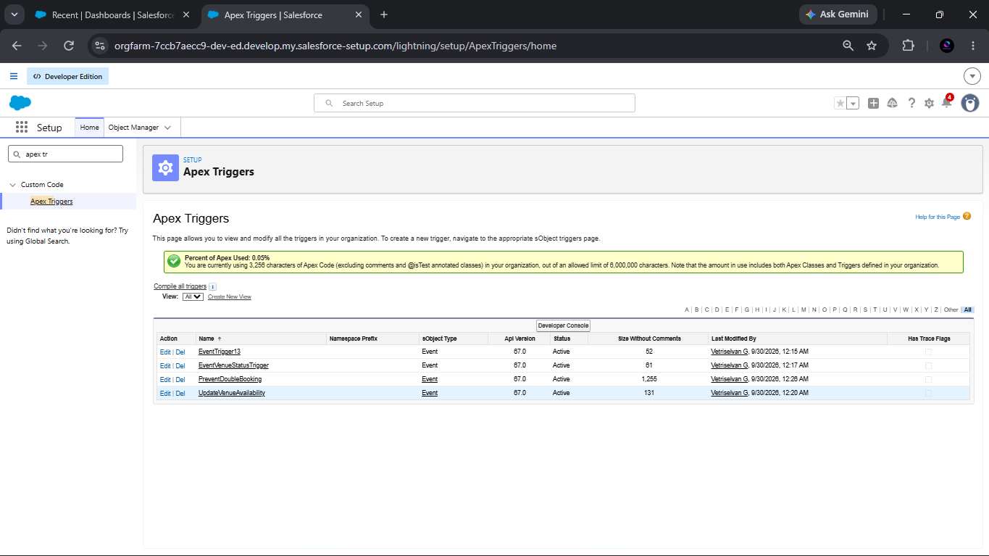
Figure 3. Apex trigger configuration for preventing venue double booking.
The trigger logic is shown in the uploaded evidence. Execution evidence for a conflict test was not provided; status is Configured; execution evidence not provided.
8.3 Batch and Scheduled Apex
BatchCompleteEvents queries past events whose Event Date is earlier than TODAY and whose status is not Completed, then updates the records to Completed. ScheduleCompleteEvents executes the batch with a batch size of 200. The reference describes a job named Daily Event Completion, configured weekly for all days at 08:00 PM.
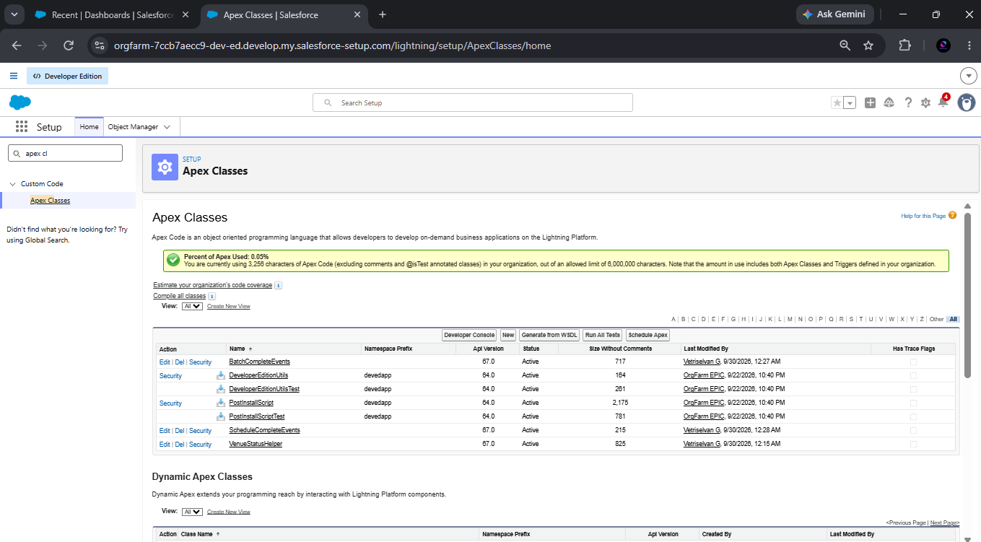
Figure 4. Salesforce Apex Classes configuration evidence.
The classes and schedule are described or shown in the sources. A particular batch execution result was not provided.
VenueStatusHelper and EventTrigger13 update venue availability based on event status. A confirmed event sets the related venue to Reserved, while a canceled event sets it to Available, using only the conditions shown in the reference implementation.
8.4 Event Cancellation Approval Process
Event_Cancellation_Process uses Event Status = Pending Cancellation as its entry criterion. The Event Owner is the initial submitter, and the process includes manager or approver routing and a Manager Review step. Initial submission notification is directed to the Event Coordinator. Final approval updates Event Status to Canceled and notifies the Event Owner. Final rejection sends a rejection notification and the configured field update sets Event Status to Rejected.
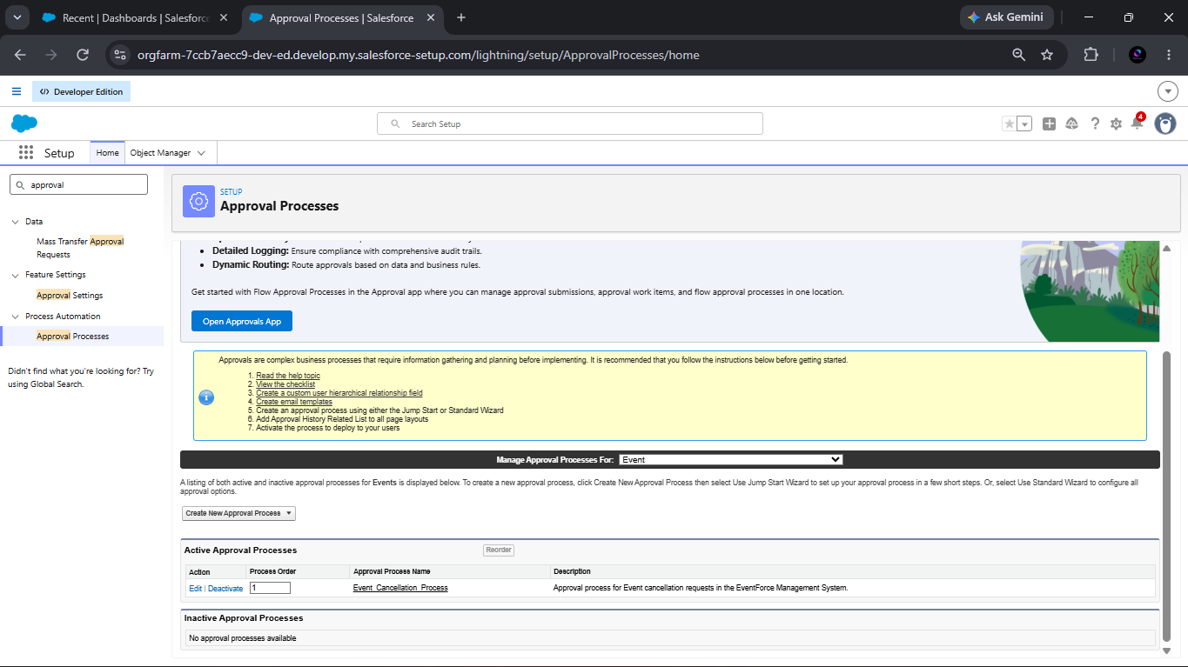
Figure 5. Salesforce Approval Processes configuration evidence.
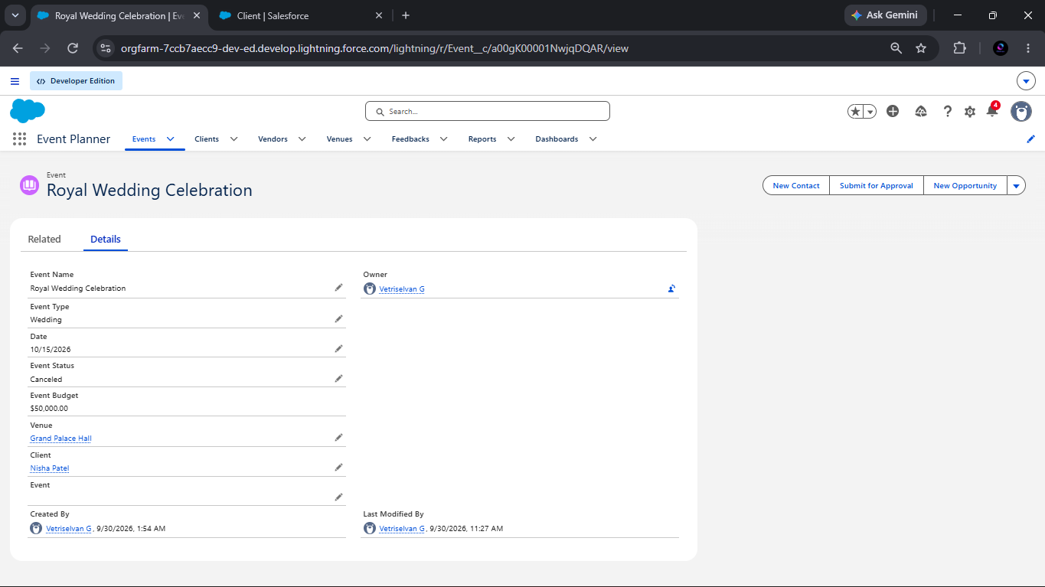
Figure 6. Event record displaying an approved or canceled outcome.
The screenshot shows a record displaying an approved/canceled outcome only; it does not establish the complete approval execution history.
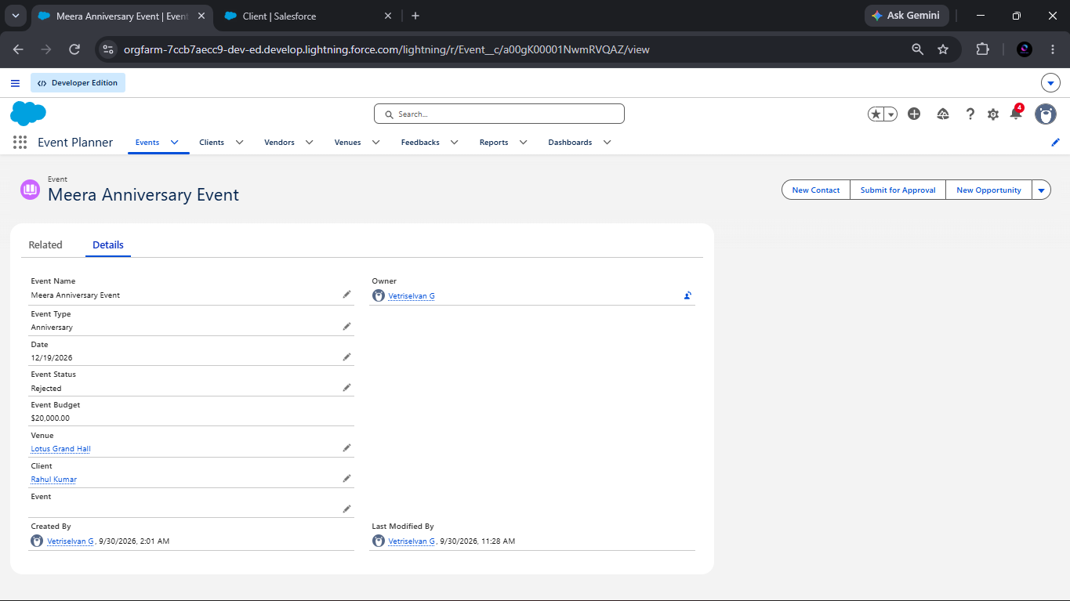
Figure 7. Event record displaying a rejected outcome.
The screenshot shows a record displaying a rejected outcome only. The reference email template text says the status reverts to Confirmed, while the configured rejection field update says Rejected. This inconsistency must be verified before production use.
8.5 Validation Rule
The active Client validation rule is named Email_Valid_Address. It uses the documented REGEX condition on Email__c and displays “Please Enter Valid Email Address” at the Email field when the condition is not satisfied.
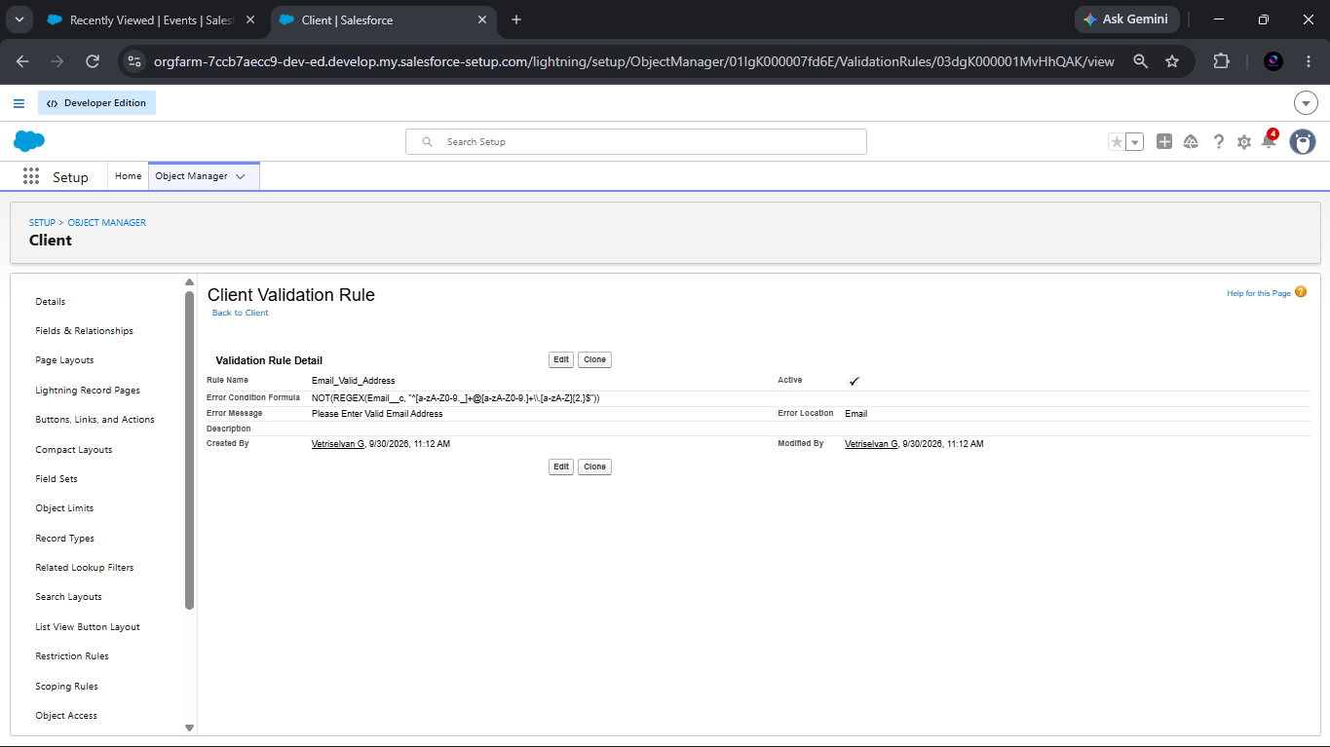
Figure 8. Salesforce Client validation rule configuration evidence.
The screenshot demonstrates the rule configuration. An invalid-entry execution result was not provided.

9. SECURITY AND ACCESS CONTROL
Profiles define object permissions, field permissions, user permissions, tab settings, app settings, Apex access, page layouts, record types, login hours, and login IP ranges. The reference describes Event Admin, Event Coordinator, Vendor Manager, and Client Profile configurations. The Users screenshot is the primary evidence for actual users and assigned profiles; additional user details are limited to what is visible there.
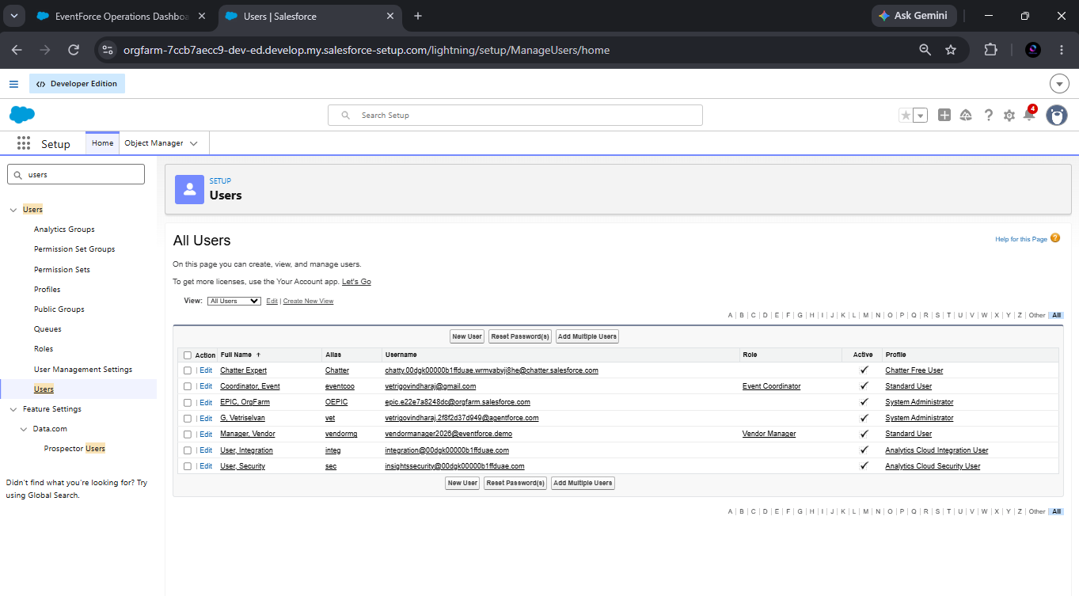
Figure 9. Salesforce Users configuration evidence.
The screenshot demonstrates a user list and assigned-profile information. It does not establish every profile permission or every user-level access outcome.
Roles define the reporting hierarchy and support record visibility. The documented roles include Event Admin, Event Coordinator, Vendor Manager, and Client.
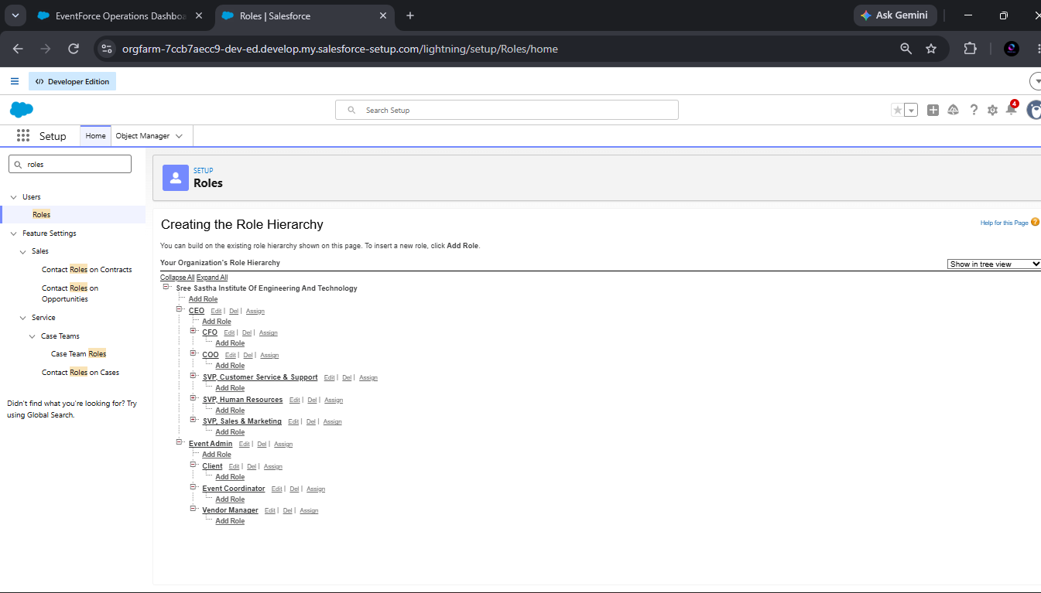
Figure 10. Salesforce role-hierarchy configuration evidence.
The Feedback Manager Permission Set grants Read, Create, Edit, and Delete permissions on Feedback in the reference configuration.
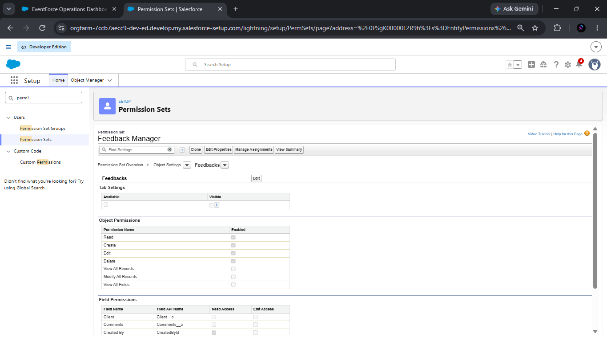
Figure 11. Salesforce Feedback Manager permission-set configuration evidence.
The screenshot demonstrates the permission-set configuration. Assignment details are limited to what is visible in the uploaded evidence.
The Event object Organization-Wide Default is Private for internal and external access according to the reference. Event_Sharing_For_Vendors extends Read Only access from records owned by Event Coordinator role members to Vendor Manager role members.
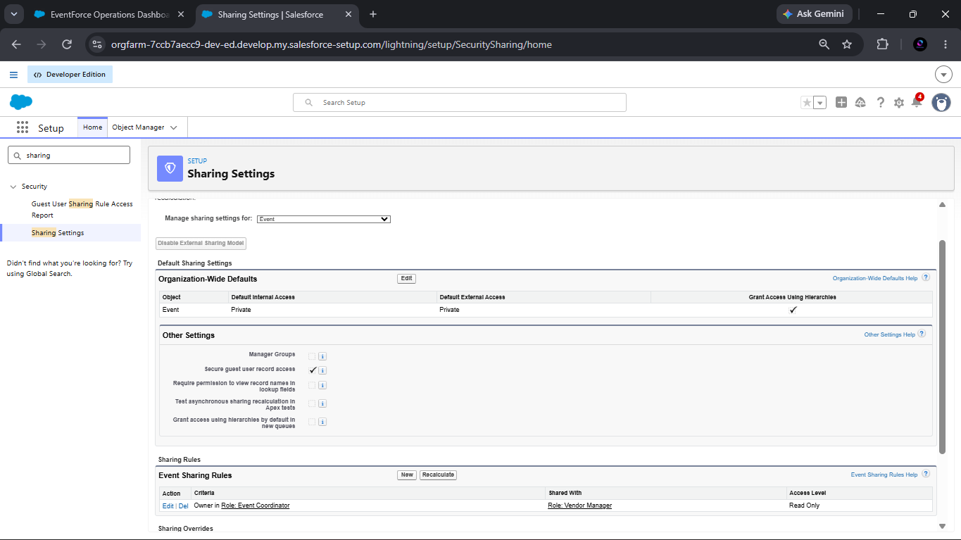
Figure 12. Salesforce Sharing Settings evidence for private access and sharing rules.
The sharing evidence supports the documented access model. A user-by-user access test result was not provided.

10. DATA IMPLEMENTATION
The implementation contains Event, Client, Vendor, Venue, Feedback, and EventVendor records as supported by the reference and uploaded evidence. The reference recommends creating at least ten records in every object before report creation; this recommendation is not, by itself, evidence that every object contains ten records.
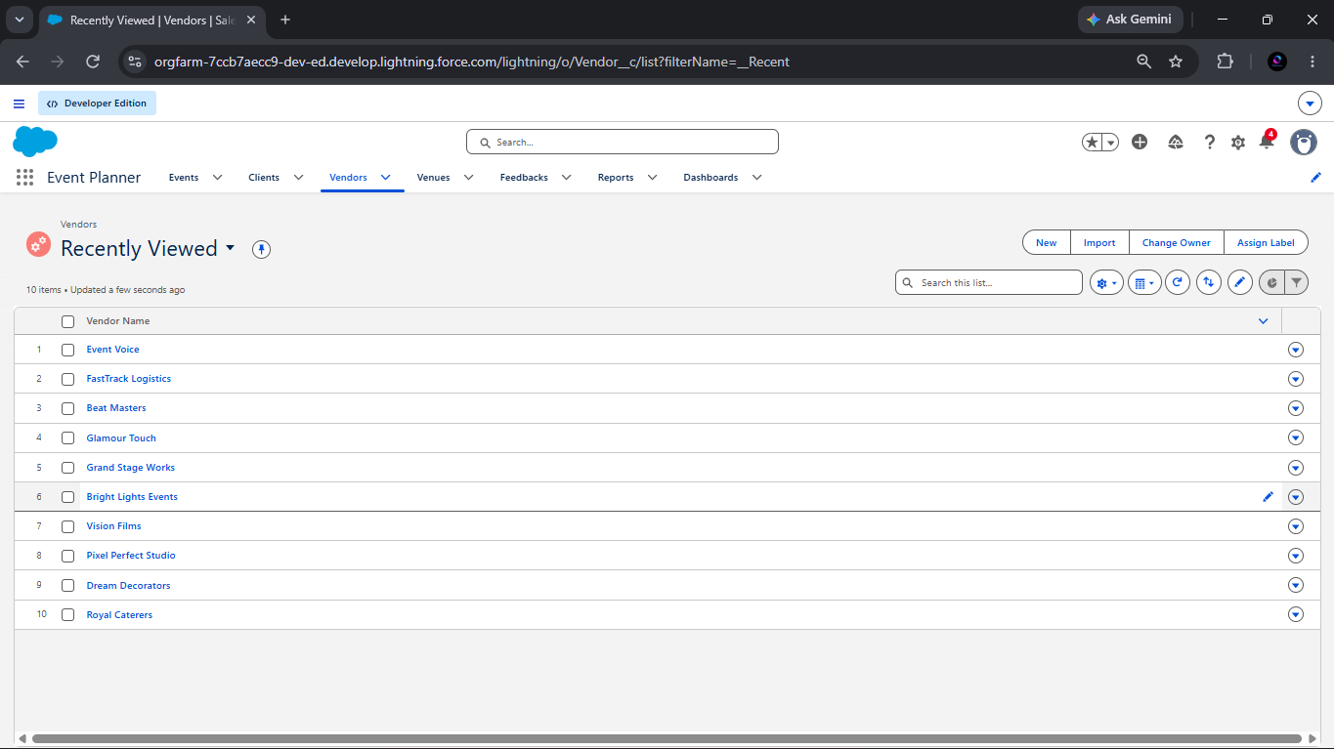
Figure 13. Vendor records visible in the Salesforce list view.
The uploaded Vendor screenshot visibly shows a list containing ten vendor records.
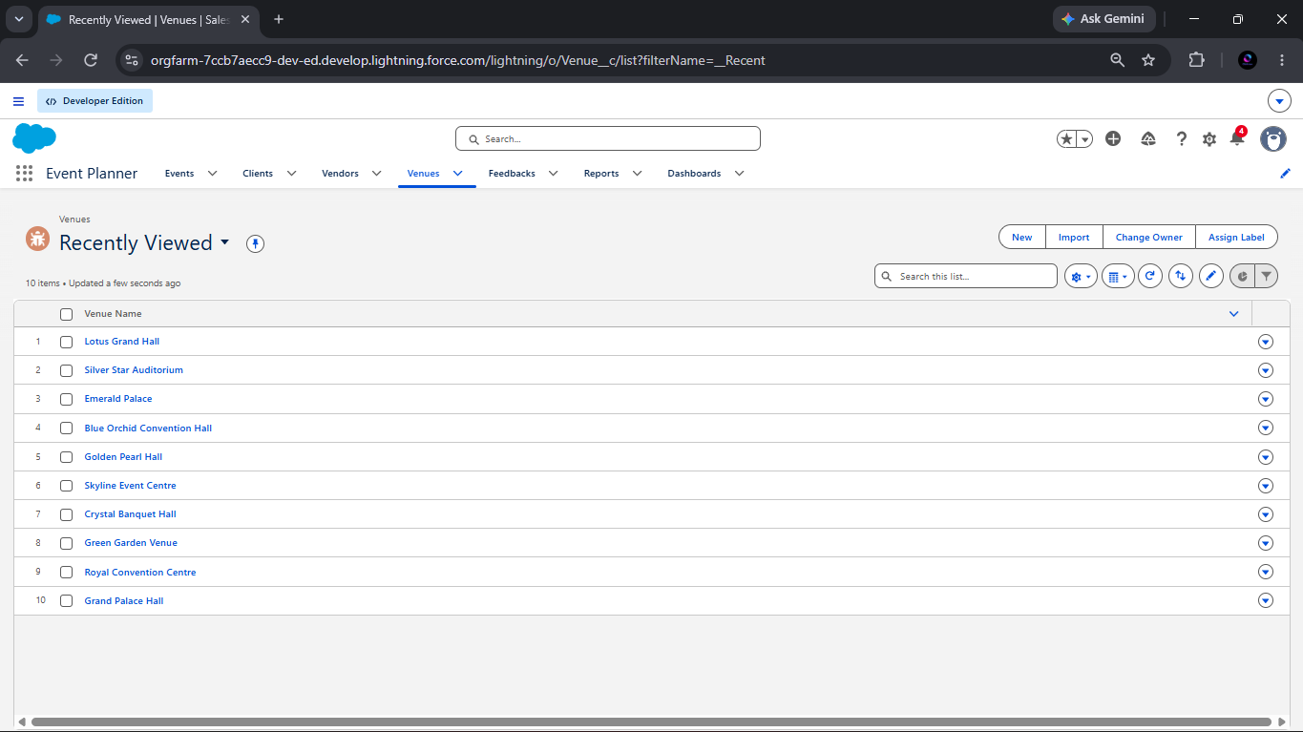
Figure 14. Venue records visible in the Salesforce list view.
The uploaded Venue screenshot visibly shows a list containing ten venue records.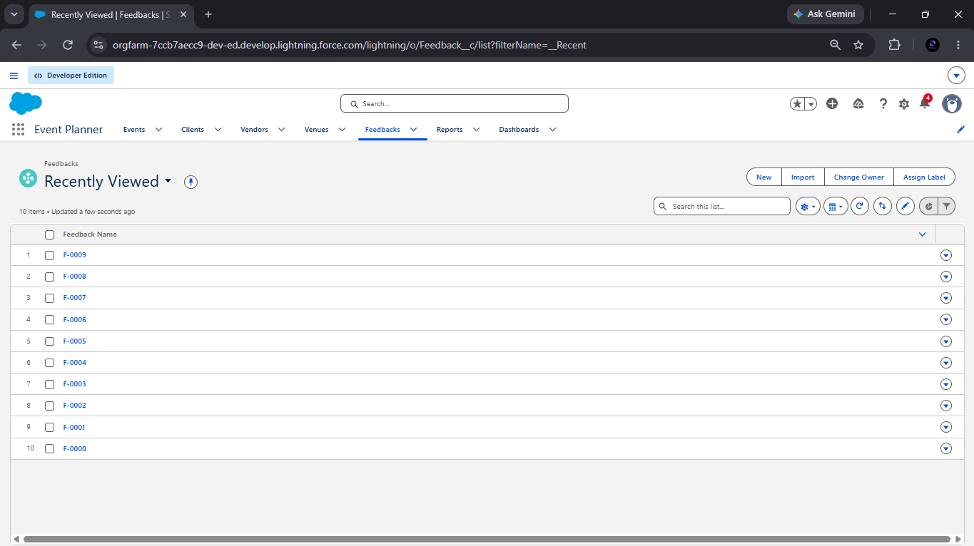
Figure 15. Feedback records visible in the Salesforce list view.
The uploaded Feedback screenshot visibly shows ten feedback records. The EventVendor record count is not provided beyond the configuration evidence in Figure 1.

11. REPORTS
The report Upcoming Events by Month provides filtered and grouped visibility into upcoming events and event budgets. Its source fields are Event Name, Event Date, Event Type, Client__r.Name, Venue__r.Name, and Event_Budget__c. The documented filters are Show Me = All Events, Event Date greater than or equal to TODAY or within the next 30 days, and Event Status not equal to Canceled. Event Date is grouped by Calendar Month, with Row Count and SUM(Event_Budget__c) summaries. The chart may use a Column or Line configuration with Event Date as the category and Row Count or SUM(Event_Budget__c) as the measure.
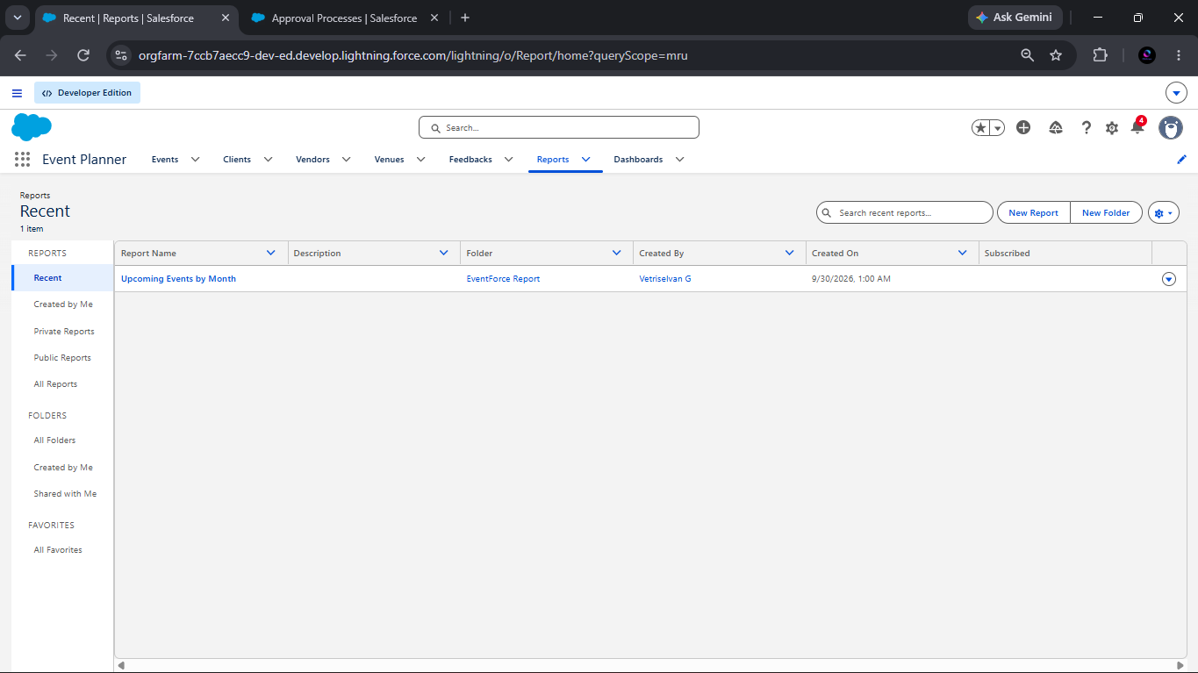
Figure 16. Salesforce Reports list showing the Upcoming Events by Month report.
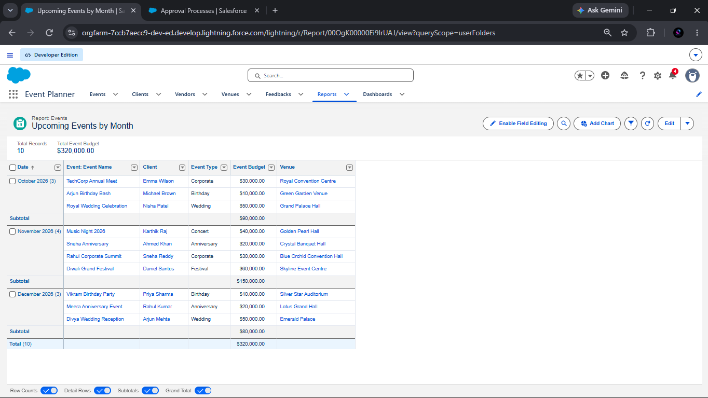
Figure 17. Upcoming Events by Month report result and budget visualization.
The report-result screenshot displays three event records and a total displayed event budget of ₹90,000. These values are treated as screenshot evidence for the displayed report only and are not generalized to the complete database.

12. DASHBOARD
The EventForce Operations Dashboard uses the Upcoming Events by Month report as a donut-chart widget. The reference configuration specifies a maximum of six displayed values, the subtitle “Upcoming Events Overview,” and a light widget theme.
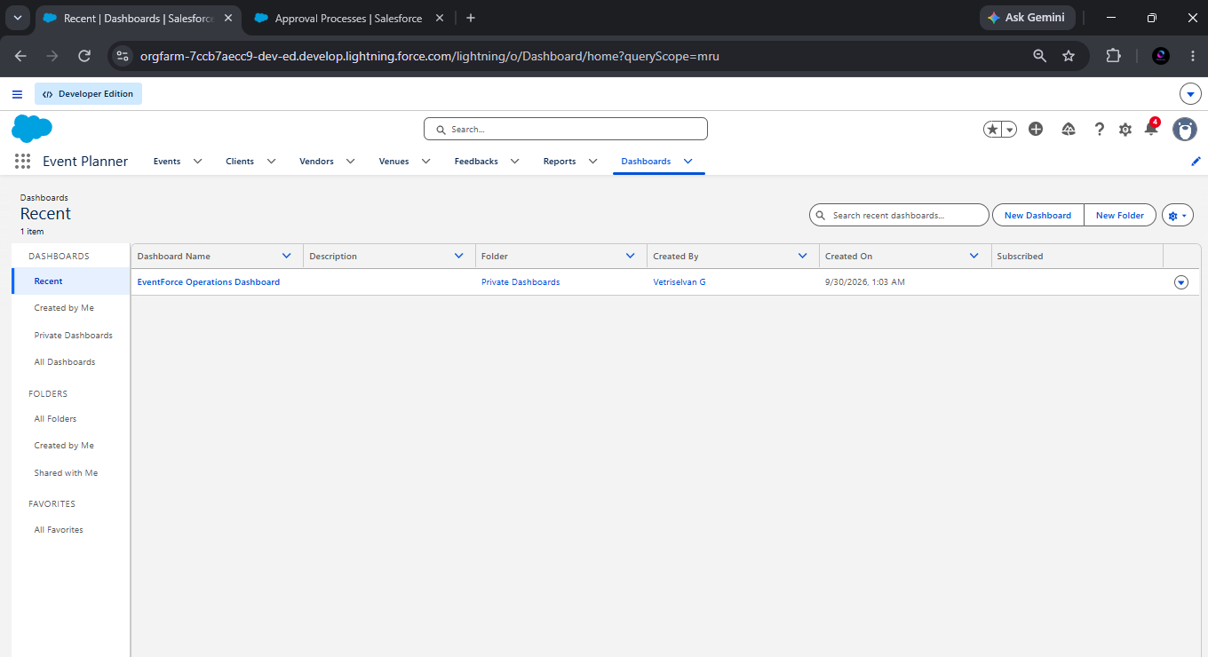
Figure 18. Salesforce dashboard list showing EventForce Operations Dashboard.
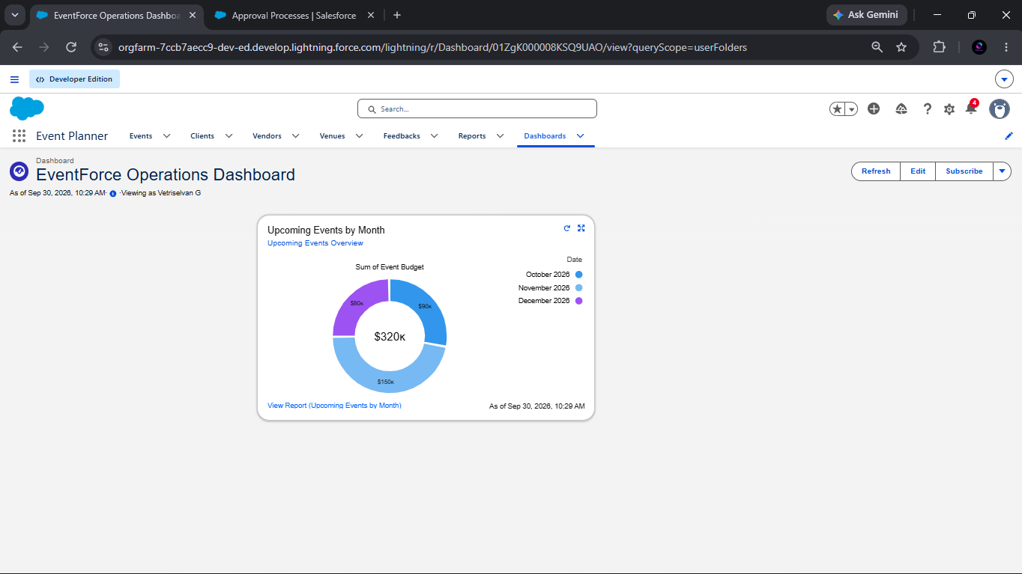
Figure 19. EventForce Operations Dashboard view with the Upcoming Events by Month visualization.
The dashboard view visibly contains the Upcoming Events by Month visualization and displays a total of ₹90k in the shown view. No broader performance conclusion is drawn from this displayed value.

13. TESTING AND RESULTS

Test Case | Function Tested | Expected Result | Actual Result | Status
3-Day Reminder Flow | Scheduled client reminder | Reminder email is scheduled for three days before a confirmed Event Date | Flow configuration is shown; email execution result not provided | CONFIGURED
Double Booking Prevention | Same Venue and Event Date conflict | Save is blocked with “This Venue is already booked on this date.” | Trigger logic is shown; execution result not provided | CONFIGURED
Scheduled/Batch Apex | Past-event completion | Past events are updated to Completed by scheduled batch | Classes and schedule are described/shown; batch execution result not provided | CONFIGURED
Cancellation Approval | Approval outcome | Approved cancellation updates status to Canceled and sends owner notification | Approved/canceled record screenshot is provided | PASS
Cancellation Rejection | Rejection outcome | Rejection notification is sent and configured field update sets status to Rejected | Rejected record screenshot is provided; reference email text contains a contradictory statement about reverting to Confirmed | PASS WITH CONFIGURATION NOTE
Client Email Validation | Invalid email prevention | Invalid email is rejected with “Please Enter Valid Email Address” | Active validation rule configuration is shown; invalid-entry result not provided | CONFIGURED
Security/Sharing | Access control | Records are restricted and shared according to configured roles and rules | Users, Roles, Permission Set, and Sharing Settings screenshots are provided; user-by-user access test result not provided | CONFIGURED
Report | Upcoming event reporting | Filtered, grouped event report displays event and budget information | Report screenshot displays three records and ₹90,000 total | PASS
Dashboard | Operational visualization | Dashboard summarizes the report visually | Dashboard screenshot displays the Upcoming Events by Month donut visualization and ₹90k total | PASS
Result interpretation: PASS is used only where the uploaded source material clearly demonstrates an outcome. CONFIGURED means the configuration is evidenced but execution results were not provided.

14. SCREENSHOT EVIDENCE
Screenshots are cross-referenced at the relevant sections of this report rather than collected only in an appendix. This approach places each item of implementation evidence beside the feature, configuration, or result that it supports.

Figure No. | Evidence description | Related section
Figure 18 | Upcoming Events by Month report result | Section 11
Figure 19 | EventForce Operations Dashboard list | Section 12
Figure 20 | EventForce Operations Dashboard view | Section 12
Figure 21 | Event Vendor fields and relationships | Section 6
Figure 22 | 3-Day Event Reminder Flow | Section 8
Figure 23 | Apex Classes | Section 8
Figure 24 | Apex Triggers | Section 8
Figure 25 | Approval Processes | Section 8
Figure 26 | cancellation approved record | Section 8
Figure 27 | cancellation rejected record | Section 8
Figure 28 | Client Validation Rule | Section 8
Figure 29 | Users | Section 9
Figure 30 | Roles | Section 9
Figure 31 | Feedback Permission Set | Section 9
Figure 32 | Sharing Settings | Section 9
Figure 33 | Vendor records | Section 10
Figure 34 | Venue records | Section 10
Figure 35 | Feedback records | Section 10
The report uses placeholders for screenshots where direct image embedding is unavailable. The placeholders identify the supplied evidence but are not claims that the screenshots are actual embedded images in this document. No unsupported evidence is claimed beyond what is visible or stated in the supplied sources.
15. DEPLOYMENT AND MAINTENANCE
In Phase 5, the EventForce configurations, customizations, and automations were built and tested in a Salesforce Developer Edition org. The Developer Edition org served as the academic deployment environment for the custom objects, fields, relationships, flows, Apex components, approvals, reports, dashboards, and access controls described in this report.
Production deployment was not performed because Developer Edition orgs are standalone environments and are not connected to production instances. The implementation therefore represents an academic deployment simulation rather than a production release.
Real deployments may use sandbox environments for validation and user acceptance testing, followed by controlled metadata migration through change sets or Salesforce DX. CI/CD tools, including GitHub pipelines, may also be used as future deployment approaches described in the reference. These approaches support repeatable promotion, version control, and review of configuration and code changes.

Maintenance area | Maintenance activity
Automation monitoring | Monitor flows, Apex jobs, and approval processes for expected scheduling, execution, and notification behavior.
Troubleshooting | Investigate access errors, permission conflicts, Apex triggers, flow logic, validation rules, and sharing settings.
Data quality | Keep event, client, vendor, venue, and feedback data accurate, complete, and consistent with the configured relationships.

16. LIMITATIONS
- Salesforce Developer Edition is an academic standalone environment and does not represent a connected production instance.
- Actual production migration was not performed.
- The reference notes license constraints in a Developer Org, including limited Salesforce license availability for users.
- Screenshot evidence does not provide execution results for every configured automation.
- The reference contains a rejection-status wording inconsistency: the email template text refers to reverting to Confirmed, while the configured field update sets the status to Rejected. This must be verified in a production-ready configuration.
17. FUTURE ENHANCEMENTS
All items in this section are proposed enhancements and are not completed features of the current academic implementation.
Proposed enhancement | Proposed direction
Production deployment | Move through a sandbox and controlled metadata migration process after appropriate validation.
Expanded analytics | Add reports and dashboards for vendor performance and client feedback.
Feedback notifications | Introduce additional automated feedback notifications if required by business validation.
Automated testing | Develop more extensive automated test classes and collect execution evidence.
Deployment workflow | Establish a stronger deployment and version-control workflow for controlled changes.
18. CONCLUSION
EventForce demonstrates how Salesforce custom objects, relationship modeling, automation, Apex logic, approvals, validation, access control, reports, and dashboards can support event-planning operations. The solution brings client, event, venue, vendor, and feedback information into a structured platform with configured business processes and operational visibility.
The implementation is an academic Salesforce Developer Edition simulation. The available evidence supports the configured data model, automation components, security setup, report, dashboard, and selected approval outcomes. It does not establish unsupported production readiness or measured performance improvements.
19. REFERENCES
- EventForce Management System – Salesforce Implementation, uploaded project reference docx.
- Uploaded Salesforce implementation screenshots, project evidence.
20. APPENDIX A: IMPLEMENTATION EVIDENCE INDEX
- Event Vendor fields and relationships — Section 6.
- 3-Day Event Reminder Flow — Section 8.
- Apex Classes — Section 8.
- Apex Triggers — Section 8.
- Cancellation approved — Section 8.
- Cancellation rejected — Section 8.
- Client Validation Rule — Section 8.
- Approval Processes — Section 8.
- Upcoming Events by Month report list and report result — Section 11.
- EventForce Operations Dashboard list and dashboard view — Section 12.
- Users — Section 9.
- Roles — Section 9.
- Sharing Settings — Section 9.
- Feedback Permission Set — Section 9.
- Feedback records — Section 10.
- Venues — Section 10.
- Vendors — Section 10.
These descriptions identify the evidence supplied for this report and do not imply additional results beyond what is visible or stated in the sources.
21. DOCUMENT CONTROL NOTE
Student Name, Register Number, Institution, and any final pagination or figure placement details marked for completion must be reviewed before DOCX export.

THANK YOU

